# **Analytical SQL project**

# **- First Question :**

Our data here is a retail transaction records which contains:

invoice_id , stock_code , quantity , Invoice_date , price , customer_id , country

It has 12858 row .. this is a sample of the data :

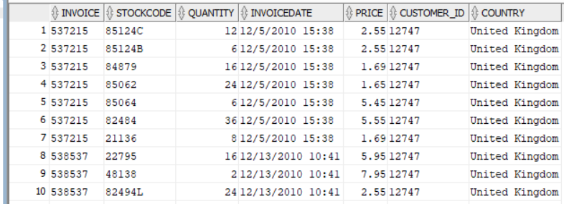

The purpose of the question was applying 5 analytical sql queries to extract useful business insights

Firstly I created a simple dashboard using power bi to show some insights about the data before analyzing it :

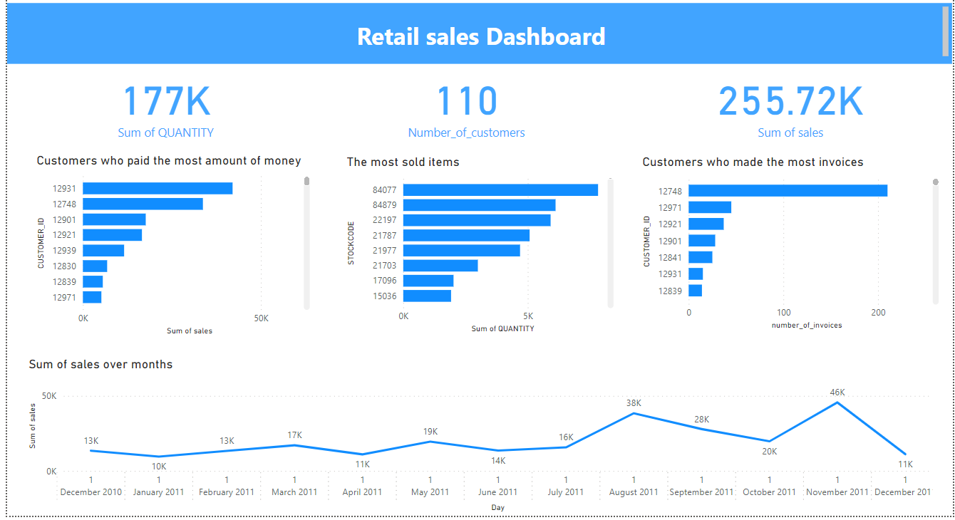

- Secondly I applied 2 sets of sql queries which contain 12 query :

the first set has **3** basic queries to explore the data and the second set has **9** analytical queries to extract business insights from the data

**- the first set :**

1 – displaying every customer_id with his total number of invoices

To know how many invoices that each customer made :

select customer_id , count(distinct invoice) as count_invoices

from tableRetail

group by customer_id

order by count_invoices desc ;

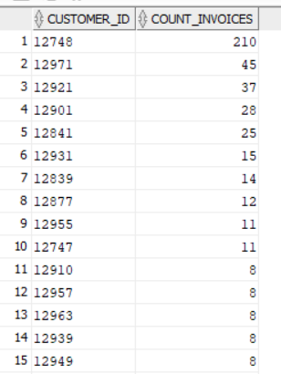

2- displaying each invoice id with its amount of money and the customer who made it to know who made the highest invoices :

select distinct invoice , sum(price * quantity) as total_price , customer_id

from tableRetail

group by invoice , customer_id

order by total_price desc ;

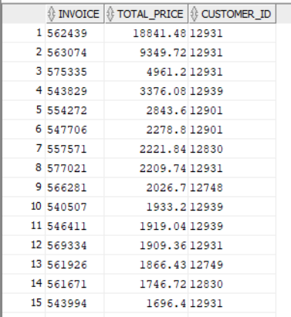

3- displaying each stock_code with its sold quantity to know which stock items with has the most quantity sold :

select distinct stockcode , sum(quantity)as count_items

from tableRetail

group by stockcode

order by count_items desc ;

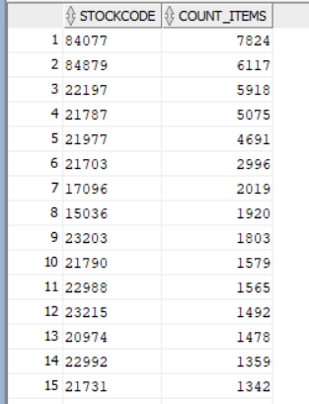

**- The second set :**

1 – displaying the top 10 customers ranked by every customer’s amount of money which has been spent in invoices

This will help us to know our loyal customers :

WITH RankedCustomers AS (

SELECT customer_id, SUM(quantity * price) AS total_sales,

RANK() OVER (ORDER BY SUM(quantity * price) DESC) AS customer_rank

FROM tableRetail

GROUP BY customer_id

)

SELECT customer_id, total_sales, customer_rank

FROM RankedCustomers

WHERE customer_rank <= 10

ORDER BY customer_rank;

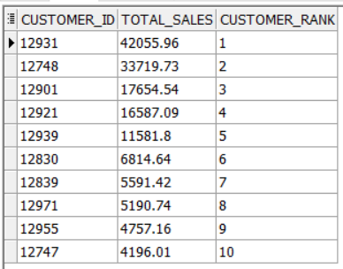

2 – displaying the monthly spending amount for each customer and its accumulating sum to track the purchasing behavior of each customer over the months and notice if there any pattern in this behavior :

select customer_id , invoiceday , customer_sales , sum(customer_sales) over (partition by customer_id order by invoiceday) as total_customer_sales

from

(select customer_id , TRUNC(TO_DATE(invoicedate, 'MM/DD/YYYY HH24:MI')) as invoiceday , sum(quantity * price) as customer_sales

from tableRetail

group by customer_id , TRUNC(TO_DATE(invoicedate, 'MM/DD/YYYY HH24:MI') )

order by customer_id , invoiceday )

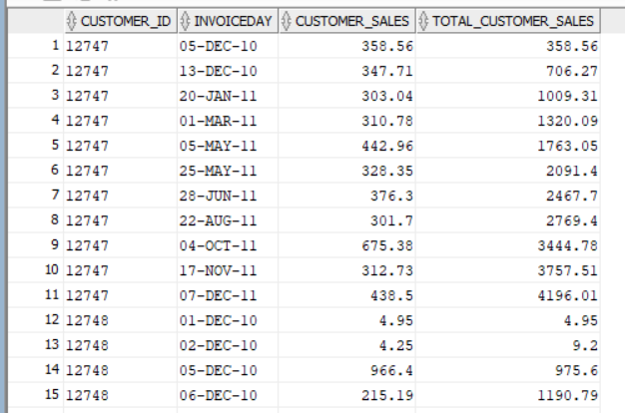

3 – tracking count of items sold of each stock item with an accumulative sum of it over months to notice if there any pattern in purchasing some stock items :

select stockcode , day , count_items_sold ,

sum(count_items_sold) over (partition by stockcode order by day asc )as total_count_items_sold

from

(select stockcode , TRUNC(TO_DATE(invoicedate, 'MM/DD/YYYY HH24:MI') )as day , sum (quantity) as count_items_sold

from tableRetail

group by stockcode , TRUNC(TO_DATE(invoicedate, 'MM/DD/YYYY HH24:MI') ) ) ;

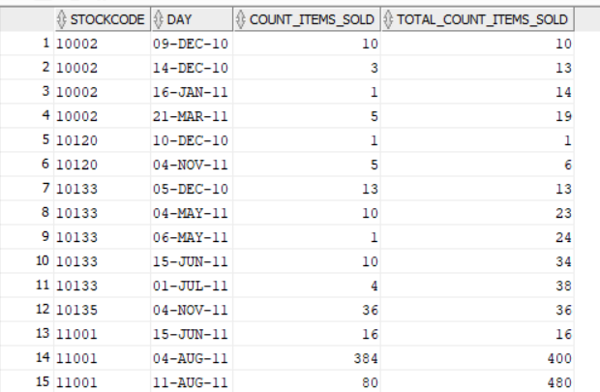

4 – displaying each day with its amount of sales to know the days with the highest amount of sales to detect if there is any pattern in them :

select distinct TRUNC(TO_DATE(invoicedate, 'MM/DD/YYYY HH24:MI') ) as day ,

sum(quantity * price) over (partition by TRUNC(TO_DATE(invoicedate, 'MM/DD/YYYY HH24:MI') ) ) as day_sales

from tableRetail

order by day_sales desc ;

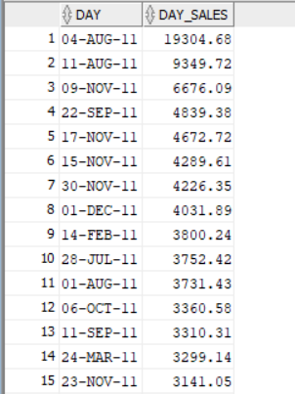

5 – displaying the count of customers who made transactions in each month and comparing it with the number of customers who made transactions in the previous month .. this help us to track the change in customers count over months and know if thsis change is positive or negative :

with months_sales AS (select count (distinct customer_id) as count_customers , TO_CHAR(TRUNC(TO_DATE(invoicedate, 'MM/DD/YYYY HH24:MI')), 'MM/YYYY') as month

from tableRetail

group by TO_CHAR(TRUNC(TO_DATE(invoicedate, 'MM/DD/YYYY HH24:MI')), 'MM/YYYY'))

select month , count_customers , (count_customers -lag(count_customers) over (order by to_date(month , 'MM/YYYY'))) as change_customers

from months_sales

order by to_date(month , 'MM/YYYY')asc ;

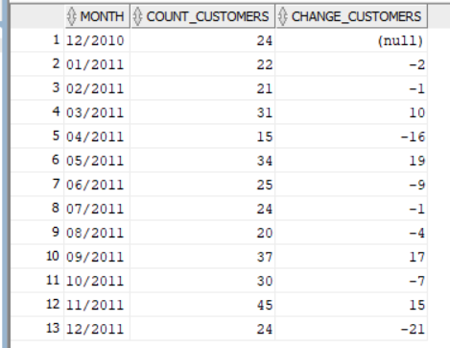

6 – displaying each month with its number of invoices and amount of sales and comparing it with the running maximum sales and the running minimum sales over months .. it will help us to assess the amount of achieved sales in each month :

with months_sales AS (select sum(quantity * price) as sales , TO_CHAR(TRUNC(TO_DATE(invoicedate, 'MM/DD/YYYY HH24:MI')), 'MM/YYYY') as month ,

count(distinct invoice) as count_invoices

from tableRetail

group by TO_CHAR(TRUNC(TO_DATE(invoicedate, 'MM/DD/YYYY HH24:MI')), 'MM/YYYY'))

select month ,count_invoices , sales , Max(sales) over(order by to_date(month , 'MM/YYYY')asc ) as max_sales , Min(sales) over(order by to_date(month , 'MM/YYYY')asc ) as min_sales

from months_sales

order by to_date(month , 'MM/YYYY')asc ;

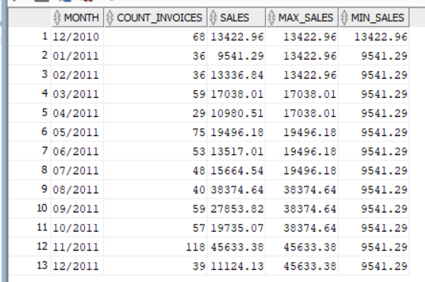

7 – I noticed change in the price of some items so I wrote this query to track the change in prices .. if the item has only one price then it will be displayed .. if the item has multiple prices then each one of them will be displayed with the last date of applying each price before changing it :

select stockcode , price , day from (

select distinct stockcode , price , lead (price) over(partition by stockcode order by TRUNC(TO_DATE(invoicedate, 'MM/DD/YYYY HH24:MI')) ) as coming_price ,TRUNC(TO_DATE(invoicedate, 'MM/DD/YYYY HH24:MI')) as day

from tableRetail

order by stockcode , day asc )

where price <> coming_price ;

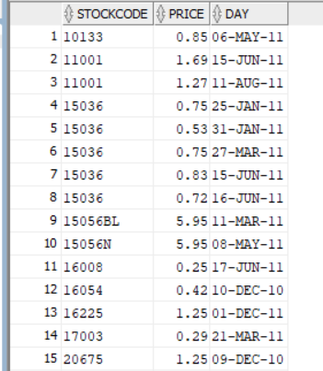

8 – I noticed there are gaps among some dates so it means there are some without any transaction.. so I tried to get every gap among dates and ordered them to know the longest gaps to analyze why our sales stopped in these intervals :

select day , next_day , (next_day - day) as difference

from (

select distinct TRUNC(TO_DATE(invoicedate, 'MM/DD/YYYY HH24:MI') ) as day ,

lead ( TRUNC(TO_DATE(invoicedate, 'MM/DD/YYYY HH24:MI') ) ) over (order by TRUNC(TO_DATE(invoicedate, 'MM/DD/YYYY HH24:MI') ) asc ) as next_day

from tableRetail )

where day <> next_day

order by difference desc ;

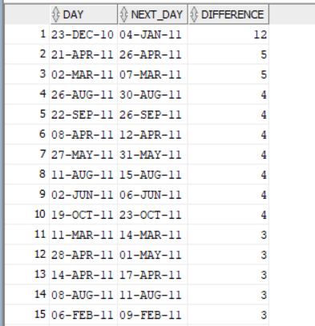

9 – I wanted to classify the customers based on their max count of days without making any transactions .. I calculated average of gaps between purchasing days for all customers and I got 33

Then I compared it with the maximum of gap days for each customer and based on the result of this comparison I gave a value (consistent) or (inconsistent) to represent the status of each customer’s purchasing behavior :

WITH sequential_days AS (

SELECT customer_id, TRUNC(TO_DATE(invoicedate, 'MM/DD/YYYY HH24:MI')) AS day,

LEAD(TRUNC(TO_DATE(invoicedate, 'MM/DD/YYYY HH24:MI'))) OVER (PARTITION BY customer_id ORDER BY TRUNC(TO_DATE(invoicedate, 'MM/DD/YYYY HH24:MI'))) AS next_day

FROM tableRetail ),

difference_between_days AS (

SELECT customer_id, day, next_day,

MAX(next_day - day) over (partition by customer_id ) AS max_gap,

round(AVG(next_day - day) OVER () )AS avg_gap

FROM sequential_days

WHERE day <> next_day )

SELECT distinct customer_id, max_gap, avg_gap ,

CASE WHEN max_gap > avg_gap THEN 'inconsistent'

ELSE 'consistent'

END AS customer_status

FROM difference_between_days ;

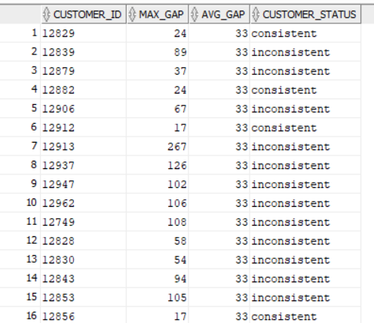

# **- Second Question :**

Our data here is the same dataset of the first question

I calculated the recency , frequency and monetary for each customer to categorize customers into different segmentations to know what is the suitable approach in dealing with each customer based on his segment :

With customer_sales as (select customer_id , sum(price * quantity) as sum_sales from tableRetail

group by customer_id) ,

RFM as (select customer_id ,

round ( ( (select max( TRUNC(TO_DATE(invoicedate, 'MM/DD/YYYY HH24:MI')) ) as last_date from tableRetail ) - max( TRUNC(TO_DATE(invoicedate, 'MM/DD/YYYY HH24:MI')) ) ) , 0 ) as recency ,

count(customer_id) as frequency , round( percent_rank() over ( order by sum (quantity * price )) , 2) as monetary from tableRetail

group by customer_id ),

RFM_scores as (

select customer_id, recency, frequency, monetary, ntile(5) over (order by recency) as r_score,

ntile(5) over (order by frequency + monetary) as fm_score

from RFM )

select customer_id, recency, frequency, monetary, r_score, fm_score ,

case

when (r_score >= 5 and fm_score >= 5)

or (r_score >= 5 and fm_score = 4)

or (r_score = 4 and fm_score >= 5) then 'champions'

when (r_score >= 5 and fm_score = 2)

or (r_score = 4 and fm_score = 2)

or (r_score = 3 and fm_score = 3)

or (r_score = 4 and fm_score >= 3) then 'potential

loyalists'

when (r_score >= 5 and fm_score = 3)

or (r_score = 4 and fm_score = 4)

or (r_score = 3 and fm_score >= 5)

or (r_score = 3 and fm_score >= 4) then 'loyal

customers'

when r_score >= 5 and fm_score = 1 then 'recent

customers'

when (r_score = 4 and fm_score = 1)

or (r_score = 3 and fm_score = 1) then 'promising'

when (r_score = 3 and fm_score = 2)

or (r_score = 2 and fm_score = 3)

or (r_score = 2 and fm_score = 2) then 'customers

needing attention'

when (r_score = 2 and fm_score >= 5)

or (r_score = 2 and fm_score = 4)

or (r_score = 1 and fm_score = 3) then 'at risk'

when (r_score = 1 and fm_score >= 5)

or (r_score = 1 and fm_score = 4) then 'cant lose

them'

when (r_score = 1 and fm_score = 2)

or (r_score = 2 and fm_score = 1) then 'hibernating'

when r_score = 1 and fm_score <= 1 then 'lost'

else 'other'

end as cust_segment from RFM_scores ;

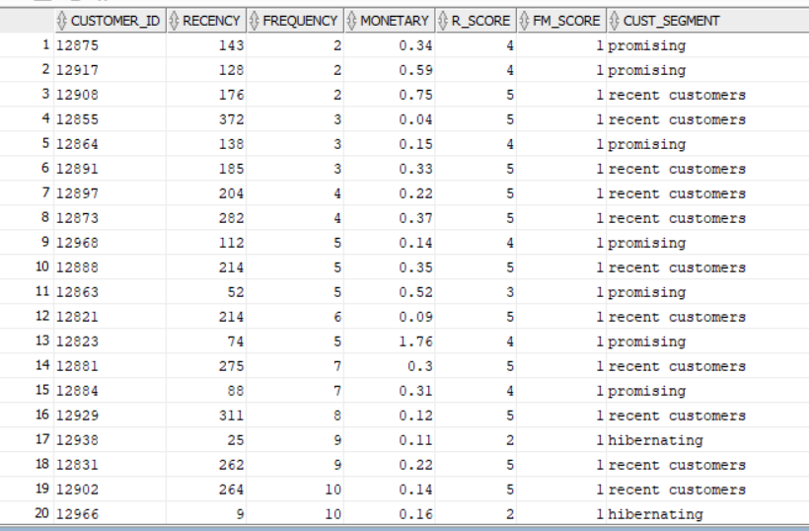

# **-Third Question :**

Our data here is transactions data which has 574396 row ,.. it contains : cust_id , calendar_dt , amt_l

The question contains 2 parts :

1 - What is the maximum number of consecutive days a customer made purchases?

WITH customer_dates AS (

SELECT cust_id,

TO_DATE(calendar_dt, 'YYYY-MM-DD') AS date_value,

ROW_NUMBER() OVER (PARTITION BY cust_id ORDER BY TO_DATE(calendar_dt, 'YYYY-MM-DD')) AS rn

FROM test

) ,

customer_intervals as (

SELECT cust_id, MIN(date_value) AS start_date,

MAX(date_value) AS end_date,

COUNT(*) AS sequential_days

FROM (

SELECT cust_id, date_value, date_value - rn AS grp

FROM customer_dates

)

GROUP BY cust_id, grp

ORDER BY cust_id, start_date )

select cust_id , max(sequential_days) as max_sequence from customer_intervals

group by cust_id ;

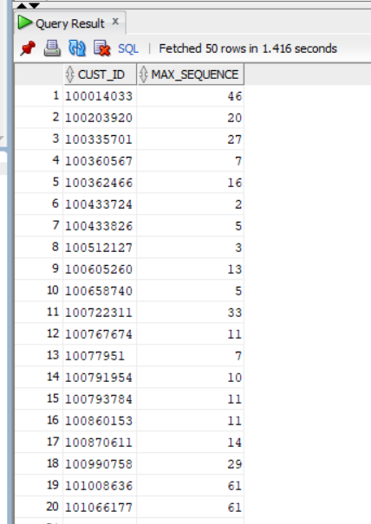

2 -On average, How many days/transactions does it take a customer to reach a spent threshold of 250 L.E?

with customers_sales as (select cust_id , calendar_dt ,count(calendar_dt) over (partition by cust_id order by TO_DATE(calendar_dt, 'YYYY-MM-DD')) as count_days , amt_l ,

sum(amt_l) over (partition by cust_id order by TO_DATE(calendar_dt, 'YYYY-MM-DD')) as total_amount

from test ) ,

high_amounts as (

select cust_id , count_days ,total_amount from customers_sales

where total_amount >=250 )

select round ( avg (count_days) )as avg_days from high_amounts

where (cust_id, total_amount) IN (select cust_id , min(total_amount) from high_amounts

group by cust_id)

order by cust_id ;

